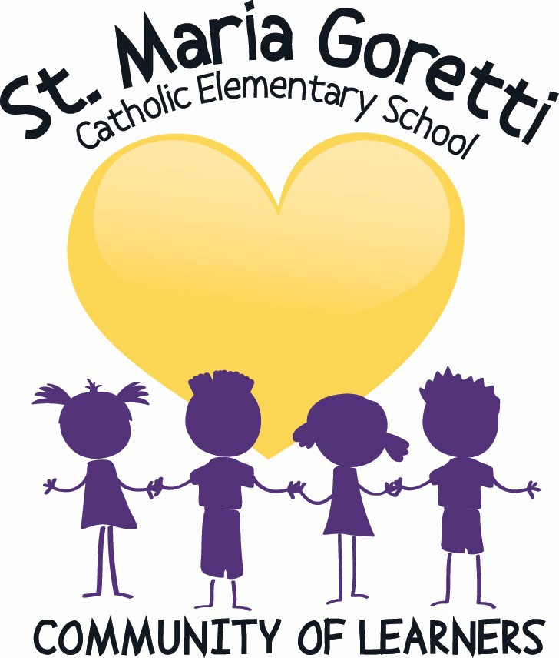

Student Code of Conduct

Statement of Purpose - Student Code of Conduct
At St. Maria Goretti School the primary focus of the Code of Conduct is to help students learn how to address issues of dispute, develop empathy and become good citizens both within and outside the school community. Students are expected to conduct themselves in a manner that safeguards and contributes to a safe and caring Catholic environment that fosters and maintains respectful and responsible behaviours. School wide expectations are communicated to our students at the beginning of the school year and reinforced through classroom discussions, assemblies, announcements, on posters around the school, in newsletters and student agendas.
The staff at St. Maria Goretti School implement the school conduct policy within the context of a Catholic school environment and in harmony with the Core Values dignity & respect, loyalty, honesty, fairness, personal & communal growth and the teachings of Jesus Christ and of the Catholic Church.

We affirm that the rights set out in the Alberta Human Rights Act and the Canadian Charter of Rights and Freedoms are afforded to all students and staff members within St. Maria Goretti School.

Student Code of Conduct in Reference to The Alberta Human Rights Act
We affirm that pursuant to the Alberta Human Rights Act and the Canadian Charter of Rights and Freedoms, students and staff members are protected from discrimination. More specifically, discrimination refers to any conduct that serves to deny or discriminate against any person or class of persons regarding any goods, services, accommodation or facilities that are customarily available to the public, and the denial or discrimination is based on race, religious beliefs, colour, gender, physical disability, mental disability, ancestry, place of origin, marital status, source of income, family status or sexual orientation.

Student Code of Conduct

Each student shall conduct themselves so to reasonably comply with the Student Code of Conduct.
Student variables such as age, maturity and individual circumstances will always be considered. Preventative procedures, supportive procedures for minor breaches of conduct, and fair, corrective interventions will all be considered when addressing major breaches of conduct.
In keeping with this spirit of community, and the recognition of ‘parents’ as the prime educators, responsibility for student growth within an orderly society is shared among the students, their parents, the district staff, and agencies and services in the broader community. Parents/Guardians play an important role in assisting teachers and principals in implementing our Student Code of Conduct and helping to contribute to a safe and caring Catholic environment.

A student will conduct himself or herself so to reasonably comply with the following code of conduct:
- Respect yourself and the rights of others in the school including all school property.
- Make sure your conduct contributes to a welcoming, caring, respectful and safe learning environment in the school that respects the diversity and fosters a sense of belonging of others in your school.
- Refrain from, report and refuse to tolerate bullying or bullying behaviour, even if it happens outside of school or school hours, or electronically.
- Assist in the prevention of violence without putting the student’s own safety or well-being at risk, by co-operating with school staff and supporting intervention efforts. Students are encouraged to report incidents of concern to school staff.
- Inform an adult you trust in a timely manner of incidents of bullying, harassment, intimidation or other safety concerns in the school.
- Act in ways that honour and appropriately represent you and your school.
- Attend school regularly and punctually as it is the law.
- Be ready to learn and actively engage in and diligently pursue your education.
- Know and comply with the rules of your school.
- Cooperate with all school staff and comply with the rules of the school.
- Be accountable for your behaviour to your teachers and other school staff.
- Contribute positively to your school and your community.

As a student at St. Maria Goretti School, whether within the school building, during the day, or by electronic means, “You will not engage in:”
- Behaviours that contravene those listed above.
- Behaviours that interfere with the learning of others and/or the school environment or that create unsafe conditions.
- Acts of bullying, harassment, or intimidation.
- Physical violence.
- Retribution against any person in the school who has intervened to prevent or report bullying or any other incident or safety concern.
- Illegal activity such as possession, use or distribution of illegal or restricted substances.
- Possession or use of weapons.
- Theft or damage to property.
- Violence of any kind at school and/or during school related activities.

Parent Responsibilities:
Parents are expected to conduct themselves in a manner that supports a safe and caring learning environment through respectful behaviour within the school community. Parents have an important role to play whether they are in the school regularly or not. Some examples include:
  - Consistently ensuring your child attends school regularly and is dropped off on time and picked up punctually.
- Take an active role in the child's educational success, including assisting the child in complying with the school conduct policy.
- Notify the school if your family is in need of social supports (food, clothing, shelter and transportation and safety).
- Speaking and responding respectfully to and about school staff.
- Speaking positively about the school, staff, other students and their families in front of your child. Voice concerns, first with the individual involved and then by contacting administrative staff.
- Have regular communication with the teacher or other school staff, and making appointments to ensure the person you want to speak with has sufficient time to have a focused conversation. Drop off and pick up times may not be ideal for you or for the teacher to have a meeting.
- Encourage, foster and advance collaborative, positive and respectful relationships with teachers, principals, other school staff and professionals who provide supports and services in the school.
- Engage in your child's school community.

Bullying (from Alberta Education “Bullying Prevention”) What is ‘Bullying’
Alberta Education defines bullying as, “...a repeated and hostile or demeaning behaviour intended to cause harm, fear or distress, including psychological harm or harm to a person's reputation. It often involves an imbalance of social or physical power.”
Bullying behaviours are a form of aggression and can be:
- Physical – For example: poking, elbowing, hitting
- Verbal – For example: name calling, insults, racist, sexist or homophobic comments, put- downs or threats
- Social – For example: gossiping, spreading rumours, excluding someone from the group, isolating, ganging up
- Cyber – For example: social or verbal bullying through the use of email, text messages or social media.

Identifying Bullying Behaviour
Below are some warning signs to help identify if a person may be engaging in bullying behaviour:
- Not understanding or caring if someone is hurt
- Unexplained increase of money, clothing or other items
- Boasting about taunting someone
- Passing off teasing as a joke
- Laughing when others get hurt
- Demonstrating aggressive behaviour
- Grouping together with some individuals and intentionally leaving others out (e.g., isolating, shunning)
- Name-calling
Bullying is the misuse of power intended to harm or humiliate someone else. People of all ages may engage in bullying behaviours.

What Bullying is NOT
Bullying behaviour is not the same as hurting someone's feelings if there is no misuse of power or a deliberate intent to cause harm. It is important to support individuals to understand the difference between these behaviours as part of learning how to build healthy relationships.

Student and Adult Roles in Stopping Bullying
Bullying behaviour is sometimes confused with conflict. Conflict is a disagreement about different beliefs, ideas, feelings or actions. It is a normal part of healthy relationships.
For example, friends may disagree over which movie to see or what game to play. Learning skills to resolve conflict appropriately is very important for building and maintaining positive relationships.
Alberta Education notes that bullying behaviour is very much a group phenomenon – 85 per cent of bullying takes place in the presence of others. By providing students with the skills and confidence to intervene, either in the moment or afterwards, schools can take a significant step toward stopping bullying behaviour.

The Role of Adults:
Intervening in a bullying incident generally stops the behaviour and sends a message that it is not acceptable. When intervening:

- Stay calm and ensure that everyone is safe.
- Listen attentively to all points of view.
- Determine if bullying is actually the case.
- Ensure support is provided to the person impacted by the behaviour, the person engaging in the behaviour and bystanders witnessing the behaviour. Make sure to take into account age, maturity and individual circumstances. It is important that the person engaging in bullying behaviour has an opportunity to understand the impact of their actions.

The Role of Students:
  - Model the behaviours you would like to see.
  - Support the person who is the target of the bullying behaviour.
  - Don't watch or encourage the behaviour - this sends a message that you think the behaviour is acceptable.
  - If it is safe, say to the person "hey, let's go" and walk away with them.
  - Check in with the person to see if they are OK and if they have someone to talk to.
  - Encourage the person to tell an adult or tell an adult that you trust.

School Response To Bullying
In instances of bullying, the school will respond to bullying whether within the school building, during the school day or by electronic means. If a child is being bullied or observes bullying, the child needs to report the incidents to his/her teacher or the school administration. If a child tells a parent about the incident, the parent needs to report the incidents to the teacher and/or school administration.
When informed of an incident of bullying, the teacher and/or school administration will investigate the incident and determine if this is a bullying situation. If it is determined that bullying has occurred, the student who has bullied others will be disciplined, in accordance with possible consequences listed below. In addition, support for the student who has been bullied will be provided, as needed.

Consequences For Unacceptable Student Behaviours
At St. Maria Goretti School we concentrate on positive behaviour and attitudes. A continuum of supports will be provided to students, based on individual needs, who are impacted by inappropriate behaviour as well as for students who engage in inappropriate behaviour.
The administration is involved depending on the severity of the infraction AND/OR at the request of the teacher. However, there are times when a student has difficulty recognizing their responsibility as a student.

Severe breaches of conduct will result in suspension in accordance with Section 31 of the Alberta School Act. In addition, possible consequences for behaviour include, but are not limited to the following:
First responses to most student conduct infractions (i.e. minor infractions) begin at the classroom level with your child’s classroom teacher.

Responses to policy infractions typically follow the following process:
- Reminder of appropriate behaviour.
- Discussion of the inappropriate behaviour with the student (logging the occurrence by the teacher).
- Note: If the infraction occurs during supervision, it is noted and reported to the child’s teacher. The homeroom teacher will decide what consequence the student will have depending on where the student is in the cycle.
- If the behaviour continues, the homeroom teacher contacts the child’s parents and explains the student’s behaviour to them.
- If the behaviour continues, the administration may become involved and the parents may then be asked to come to the school OR a telephone call is made to parents after which parents, student and involved staff meet. The staff member goes over the behaviour of concern with the parent and the student and parents are both informed that if the inappropriate behavior continues, either an in-school or an out-of-school suspension may occur, depending on the circumstances.
- If the behaviour continues, school administration may resort to either in-school suspension or out-of-school suspension.
- In extreme circumstances, district personnel would become involved and further action may be taken.
Other responses to student misconduct include, but are not limited to, the following:
  - verbal reprimand
  - phone call home to parent
  - restriction of privileges and activities
  - walk with a supervisor at recess
  - parental involvement
  - parent-student conference with school staff
  - verbal or written apology by student
  - restitution/compensation for damaged property
  - loss of privileges (e.g. field trips, assemblies, classroom and/or extra curricular activities, special days)
  - problem solving, monitoring or reviewing behaviour expectations and involvement with Emotional Behaviour Specialist
  - replacement or repair of damaged property

  - temporary exclusion of student from class
  - bus suspension for students riding the bus
  - in-school/out-of school suspension in accordance with Section 12 of the School Act
  - referral to Attendance Board
  - involvement of outside agencies (i.e. police/social services)
  - recommendation for expulsion (In consultation with District personnel)

Suspensions
Severe breaches of conduct can result in suspension in accordance with Section 31 of the Alberta Education Act. In addition, possible consequences for behaviour include, but are not limited to the following:
  - opposition to authority
  - aggressive behaviour such as fighting
  - willful disobedience
  - vandalism or theft
  - use of inappropriate language and gestures
  - use and possession of weapons
  - bullying or aggression
  - cyber bullying
  - discriminatory behavior
An out of school suspension can vary from 1 to 5 days. The student and parent/guardian must discuss/meet with an administrator either before or after the student’s return in order to return after an Out-of-School Suspension.
During an out-of-school suspension, a student will:
  - receive homework to be completed at home for the next school day.
  - Have a letter regarding the suspension placed on file, which will remain on file for 2 years, in accordance with Division policy.
At St. Maria Goretti School, it is our goal to provide students, staff, and families a safe and caring Catholic learning environment that fosters and maintains respectful and responsible behaviours.

